Dr. Eick

Fundamentals of Artificial Intelligence

COSC 4368

Solution Sketches Midterm Exam

B

Wednesday, March 9, 2022

Name:

Student id:

- A* & Best-first Search & Backtracking (15 points):
- Reinforcement Learning (12 points):
- SA and Hill Climbing (8 points):
- Game Theory (5 points):
- Constraint Satisfaction Problems (11 points):
- Miscellaneous Questions (13 points):

Σ (out of 64):

Number Grade:
The exam is “open books and notes”, but no computers and cell phones allowed; you have 72 minutes to complete the exam. Write all your answers on this document (you can use back sides!).

1) Best-first Search and A* [15]
Consider the search space below, where S is the start node and G1 and G2 satisfy the goal test. Arcs are labeled with the cost of traversing them and the estimated cost to a goal (the h function itself) is reported inside nodes.

For each of the following search strategies, indicate which goal state is reached (if any) and list, in order, all the states popped off of the OPEN list. When all else is equal, nodes should be removed from OPEN in alphabetical order.

a) Best-First-Search (using function h only) [2]
Goal state reached: G1 [1]
States popped off OPEN: S D G1 [2]

b) A* (using f=g+h)[4]

Goal state reached: G1 [1}
States popped off OPEN: S A D G1 [3]
No partial credit!
D
5

B
4

8
DDD
3
3

2
25
1
7
2
1
5
2
9
A 9
10

G1
0
E
7

C
8

G2
0
S
9

2
5
8
4
1
4
7
Problem 1 continued
b) Compare Backtracking (assuming it is used with an intelligent operator selection function) with Best First search (assuming it is used with an intelligent state evaluation function). What are the advantages/disadvantages of each search strategy? [6]

see solution A

c) Assume h1 and h2 are admissible heuristics! Using those we define two more heuristics h3(x)=max(h1(x),h2(x)) and h4(x)=min(h1(x),h2(x)). Would you prefer using h3 or h4 in conjunction with A*? Give reasons for your answer! [3]

I would prefer h3 [1] as ∀s h3(s)≥h4(s) and as according to the textbook/lecture heuristics h(s) that more closely approximate the true cost of reaching a goal state from s are more efficient, finding a goal state more quickly/expending less states.

2) Reinforcement Learning
a) Consider the following World called DEF is given:
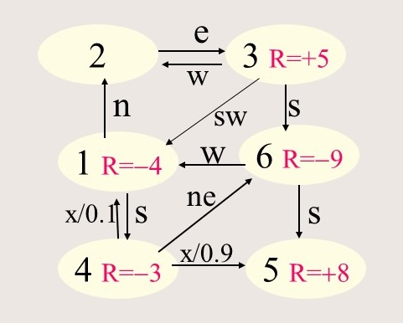
Give the Bellman equations for states 2, 3 and 4 of the DEF World; assume γ=0.5! [4]

U(2) = 0 + 0.5*U(3)
U(3) = 5 + 0.5*max(U(2), U(1), U(6))
U(4) = -3 + 0.5*max(U(1)*0.1+U(5)*0.9, U(6))

DEF World
b) Now we apply temporal difference learning, assuming the agent starts in state 3 and applies the operator sequence sw-n-e; assume that the initial utilities are 0; what are the new utilities of the states visited by the agent? Also assume α=0.5 and γ=1! [6]

U^{Π} (s) U^{Π} (s) + α [ R(s) + γ U^{Π} (s’) - U^{Π} (s) ]

U(3) = U(3) + 0.5[R(3) + 1*U(1_{sw}) – U(3)]
= 0 + 0.5[5 + 0 – 0] = 2.5

U(1) = U(1) + 0.5[R(1) + 1*U(2_{north}) – U(1)]
= 0 + 0.5[-4 + 0 – 0] = -2

U(2) = U(2) + 0.5[R(2) + 1*U(3_{east}) – U(2)]
= 0 + 0.5[0 + 2.5 – 0] = 1.25

c) Assume you have a policy that always selects the action that leads to the state with the highest expected utility only in 80% of the cases and not always. Are there any advantages not always going to the state with the highest utility? [2]
facilitates exploration/ learning how to act in unknown worlds [2] or allows to deal with changing worlds [2]

3) SA, and Hill Climbing [8]
a) What advantages do you see in using local search techniques, such as hill climbing over backtracking or best first search? What disadvantages do you see in using local search techniques over backtracking or best first search? [4]
advantages: see solution A [2]
disadvantages: sometimes get stuck [1], only able to find the local maximum [2] sensitive to the starting position/initial state from which the search starts[1] at most 2 points for disadvantages mentioned.

Problem 3 continued
b) Simulated annealing employs a temperature parameter which is decreased based on a cooling schedule when solving a search problem. What role does the temperature play in a simulated annealing algorithm? What is the motivation for this reducing the temperature? [4]

see solution A

4) Game Theory [5]
What is the Nash Equilibrium for the following parallel game, whose payoff matrix is depicted below [3]? Player 1 has actions T, B, and R whereas Player 2 had actions D, E and F. What is the main property of a Nash Equilibrium? [2]

Add underlined choices, choices in red to the solution depicted below!

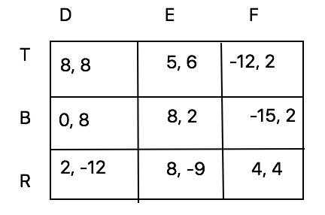
There is 2 Nash Equilibrium: (T,D), (R, F)

If one player changes its action, her reward will not increase [2]

5. Discrete CSPs (11 points)

Assume the following constraint satisfaction problem in which variables A, B, C, D take values in {1,…,100}is given:
- Constraints:
  - (C1) A<B
  - (C2) C*D + B*D*D=D*D*D*A
  - (C3) B*B*C + A*B*D=A*A*D*D
A brute force solution to this problem could look as follows:
FOR A=1,…,A=100
FOR B=1,…,B=100
FOR C=1,…,C=100
FOR D=1,…,D=100 DO {
IF C1 and C2 THEN WriteSolution(A,B,C,D)}
Give the code of a more efficient solution to this problem which uses less loops and/or less iterations inside the loop. Briefly describe the idea of your solution! Solutions which speed up the solution for the above CSP more will get more points.

We first transform equation (C2) by dividing each side by D obtaining

(C2’) C + B*D=D*D*A
From this we obtain equation (C2’’) which allows us to eliminate variable C
(C’’) C= (D*D*A −B*D)
and by substituting C3 in equation (C3) we get equation C3’:
(C3’) B*B*(D*D*A −B*D) + A*B*D=A*A*D*D

Additionally considering that A<B, we obtain the following much more efficient loop to solve the above CSP:

FOR A=1,…,A=100
FOR B=A+1,…,B= 100
FOR D=1,…,D=100 DO
{ IF C3’ THEN C= (D*D*A −B*D); WriteSolution(A,B,C,D)}

If they only consider eliminating variable D: 7 points
If they only take advantage of B<A: 4 points
However, they might propose other approaches to simplify the loop which might deserve partial (or unlikely full) credit.

6) Miscellaneous Questions (13 points)
a) For most game with complete information, such as Go and chess, it is not feasible to construct the complete search tree; how do game-playing programs cope with this challenge? [3]

see solution A

b) Do the solution min-max search and alpha-beta search differ from each other? [1]

No

c) What role do mutation operators play in evolutionary computing systems? [2]

It is an exploration operator / introduces something new [2] performs random changes of the solution to be mutated [1] at most 2 points

d) Evolutionary computing systems employ Darwinian Evolution / Survival of the fittest in the search for good solutions. Explain! Describe an approach that could be used to simulate Darwinian Evolutions! [4]

See solution A

e) What is the goal of reinforcement learning? [3]

See solution A

and chooses a random action otherwise!

