March 14, 2019
Encounters Running on the Camino del Oleoducto in Panama

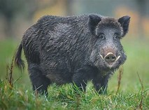

Christoph F. Eick

In 2002 I decided to visit Panama for a 10-day vacation. At this time Panama was not a major tourism spot, but I found a travel agency that booked all the hotels and transfers for me, as well as a guided rainforest hike and a rafting trip near Boquete in Western Panama. One spot I visited is the Gamboa Rainforest Resort which is located 20 miles inland very close to the Panama Canal about 30 miles south of Colon, Panama which is at the Atlantic Ocean.

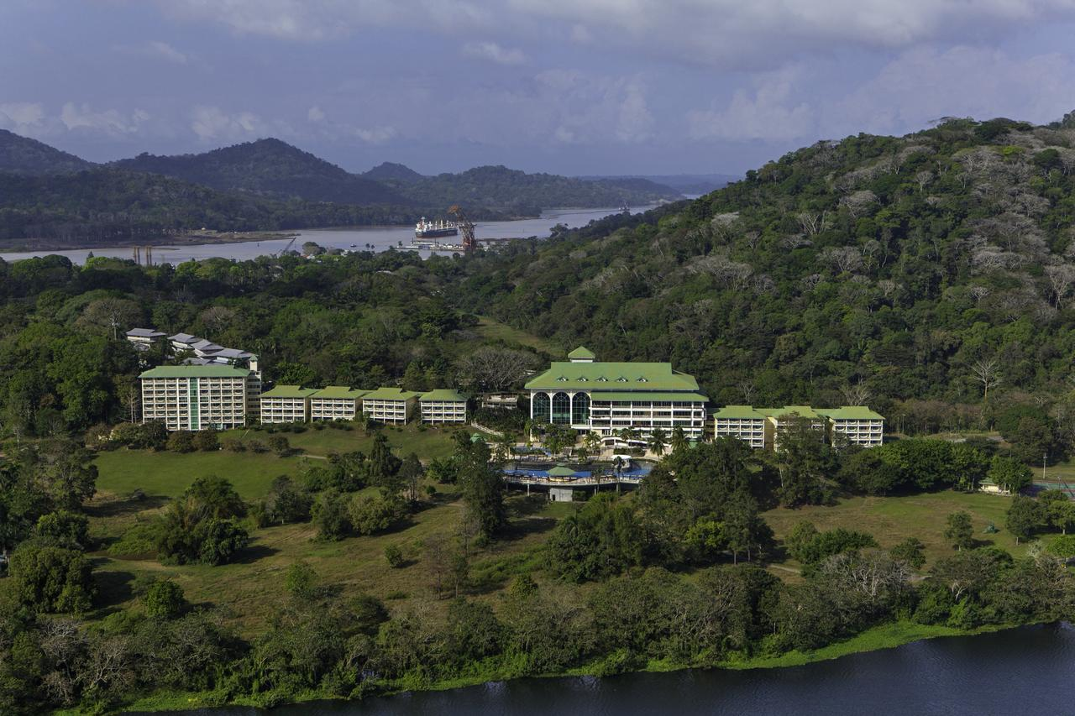
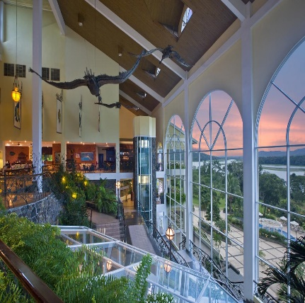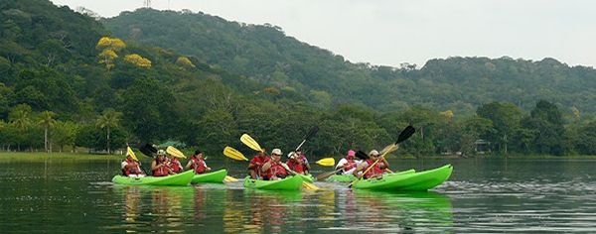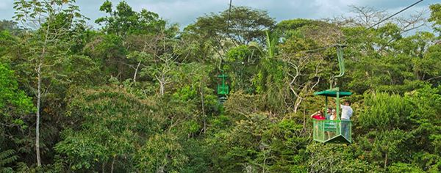
Fig. 1: Photos Gamboa Rainforest Resort.

On August 5, 2012 I set out for a hike through the rain forest with a guide. Challenges of this hike included, the density of the vegetation, the unevenness of the land and the lack of paths, the hostility of most rainforest plants most of which have sharp stickers—I finished the hike with a lot of cuts on my arms—and dealing with the tons of mosquitos and other insects, which makes it a good test site for mosquito repellents: my repellent kind of worked but hundreds of insects were still flying 247 around me during the hike, and finally the high humidity and temperature. During the hike we saw many nice flowers, termite hills, and the density and the 3D rainforest vegetation is quite impressive, and we heard a lot of animals but saw very few.

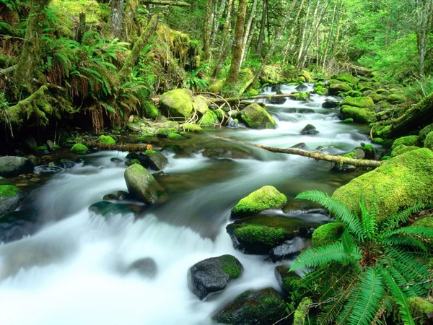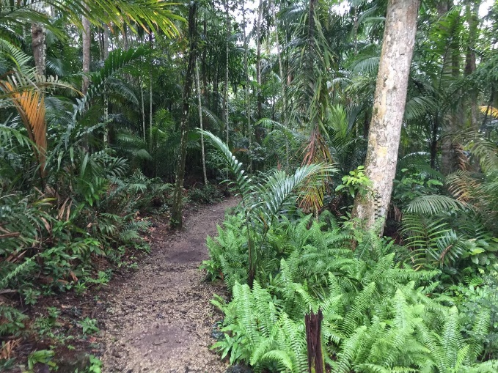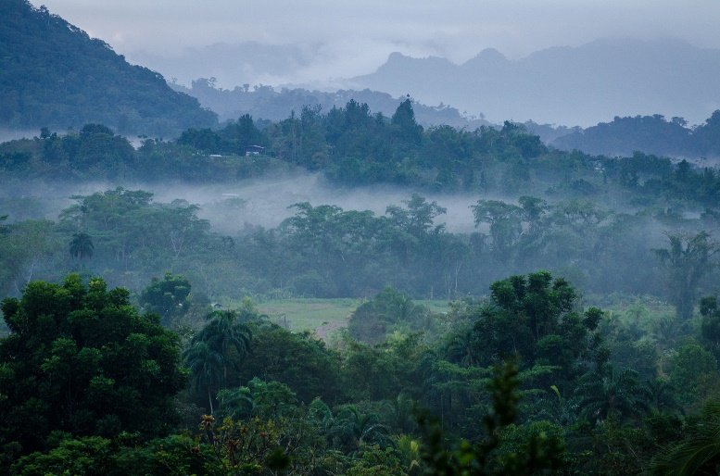

Fig. 2: Panama Rainforest Photos.

The next day August 6, 2002 I decided to do an 18 miles out and back long run going north/north-west from the resort on the Camino del Oleoducto that passes through the Soberania National Park in Panama; the Camino del Oleoducto—also called Pipeline Road on the internet— is an old, abandoned road that originally connected Gamboa to Colon. At that time, although it was early August, I was already in really good shape as I was training for the 2002 New York City and the 2003 Houston Marathon: I would place 128th/4737 5 months later when I ran the Chevron Houston Marathon on January 19, 2003. Running through the rainforest on a “former” road had the big advantage of not being bothered by mosquitos and other critters at all: if you run in the middle of the road the15 feet cushion on each side is just enough to avoid the attention of the critters. The trail was a mostly wet, but not very wet dirt trail with very few stony sections.

Equipped with a water carrier, 4 GUs I started my 18M run; initially, I was surrounded by a lot of people for the first two miles, mostly bird watching groups. However, soon the trail became obstructed by a lot of fallen trees. Moreover, the trail goes over a lot of bridges, but after 2 miles into the run there was a lot of debris on some on some bridges and other bridges showed a lot of decay and became quite an adventure to cross some those bridges and to navigate over all those fallen trees. The trail had occasionally a few wet spots and was occasional slippery, but in general it was quite good to run on. I heard a lot of birds, but saw only a one large very colorful bird. After I ran 3 miles, I was completely alone, except a couple of hikers I ran past near the 4 mile marker.

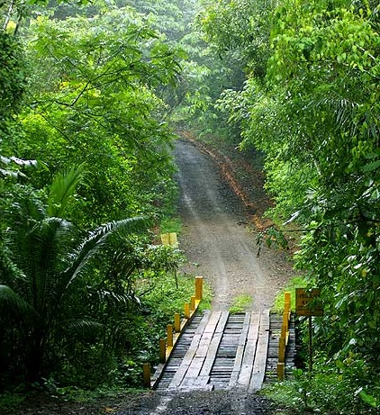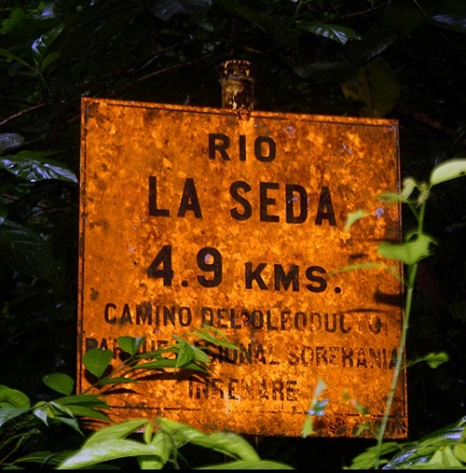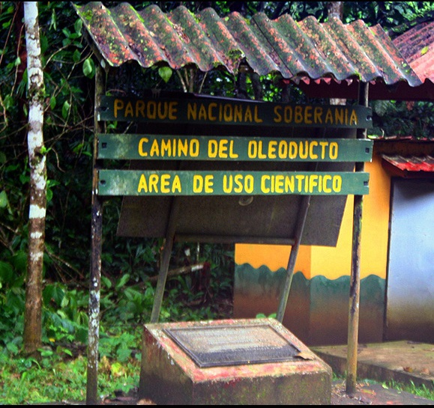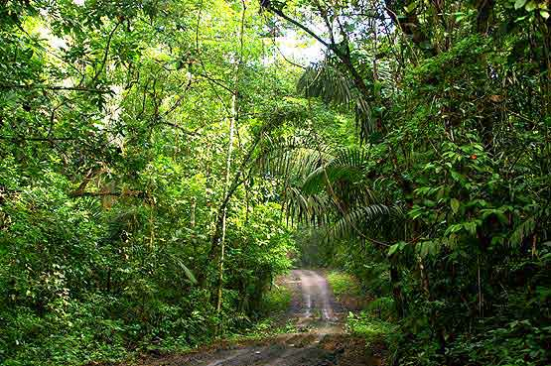

Fig. 3: Photos taken along the Camino del Oleoducto.

The run become more strenuous as it was quite hot with high humidity and rolling terrain and my pace decreased significantly after running 6 miles. Pretty soon after that I noticed a lot of noises in the forest I was passing through and could initially not figure out what the noise was all about. But then I looked to my left back and I saw 2 wild pigs, and I looked to left in front and I also saw a single wild pig, and then I looked to right back and saw 3 wild pigs, but I did not see any wild pigs in the front to the right; after looking more closely I saw about 15 wild pigs total. I was not sure what would be happening next; wild pigs/hogs have been known to kill big dogs in the US; I hoped those hogs were not as bad as those in the movie Hannibal which I saw the year before. Moreover, the hogs did not like me to be in their territory and stated to make grunting noises, and I got somewhat scared. Based on all those things happening—although I was already somewhat tired—I slowly increased my speed, looking occasionally back hoping that none of those hogs were following me. I ran 2 more miles and soon I reached the 9M “marker”, and it was time to turn around to run back to the Gamboa Rainforest Resort.

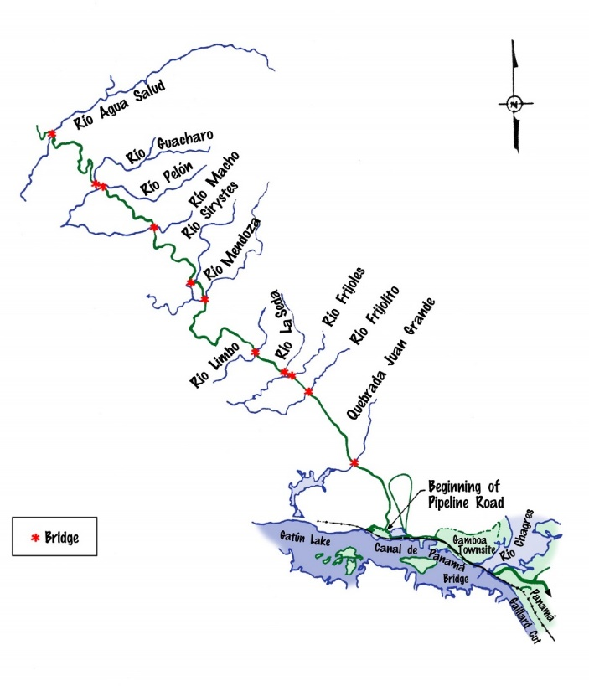
Fig. 4: Map of the Camino del Oleoducto Road.
After running 3 miles I was getting close to the spot again where I encountered the herd of hogs. I somewhat worried about more hog encounters, but, luckily the herd of wild pigs was gone. I felt quite tired on the last 4 miles, taking a couple of walking breaks near the end. Finally, I got back to the resort, running 18 miles in 3 hours, 7 minutes and 23 seconds—not counting water breaks and other stops—and below you see the entry of the run in my training log I made shortly after I finished the run.
8/6 | 18M | cont | 3:07:23! | Camino del Oleoducto | SNC | 6/10 | Parallel to the Panama Canal on a somewhat wet, occasionally slippery, rolling mostly dirt, sometimes stone trail; saw a herd of wild, not very high pigs that were defending the trail aggressively. The run felt quite hard although I was running quite slowly in almost 100% humidity.

Fig. 4: Christoph F. Eick Running Log Entry taken from: http://www2.cs.uh.edu/~ceick/rrr/e2002-log.html

