2023 Habanero Hundred Race Report

Christoph F. Eick finished on Saturday, August 12, 2023 the Habanero Hundred 20K Race in 4:21:32 placing 27th of 42 finishers (the temperature at the 12:30p race start was 99.5 / 102 in the sun and reached a high at 3:30p of 104.2/106 in the sun and the temperature at 5p when I finished the race was 102.0/104 in the sun; this was the warmest Habanero 100 ever, none of the previous races had temperatures above 100). The race organizers went through nearly 10,000 lbs. of ice, most of that in the very first 12 hours!

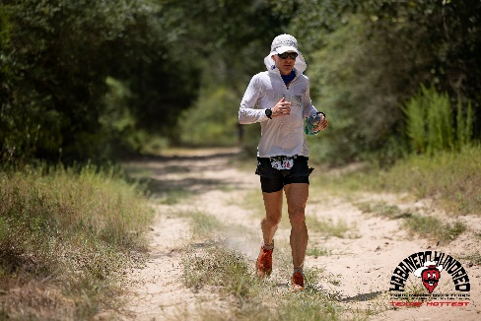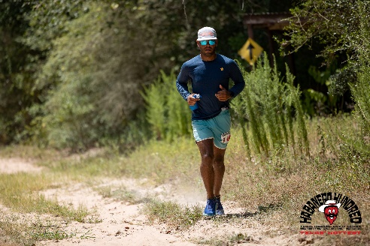

Originally, I wanted to run-walk the race with 40% running, but decided my body would get “too hot” doing that on August 12 and walked the whole 20K distance. I was moving along smoothly for the first 11 miles, but then I was experiencing leg cramps and completed the remaining 1.4 miles of the course with significant difficulties.

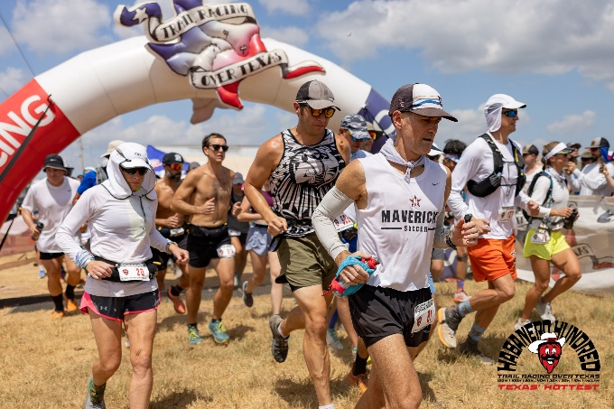

HABANERO | TROT (trailracingovertexas.com) 22 participants finished this year’s 100 Mile race, but 57 did not; Ross Ford won the race in 20:47:09 and Kelly Swanson was second overall in 22:28:24. The cutoff time for the 100 Mile race was 30 hours, and 9 finishers completed the race in “the last hour”. I had to wait in line for 40 minutes to get my race numbers, but the volunteers at the aid stations and on the course “were great”!

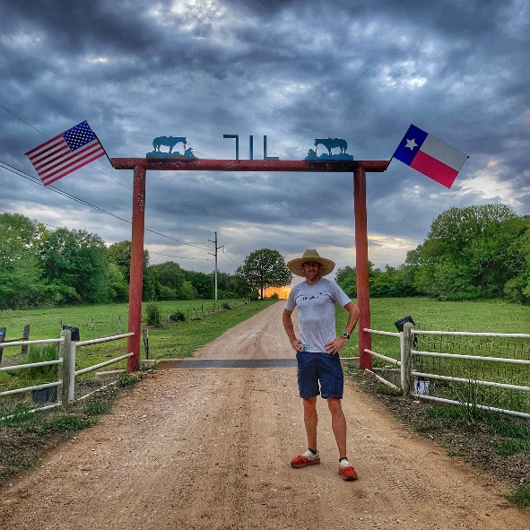
The race was run at the beautiful 7IL Ranch in Cat Spring, Texas: 7IL Ranch - Equestrian Trails, Equestrian Stables, Country Wedding; the course is mostly run on grass and hard dirt but about 20% of the course surface was on beach-like sand this year—a lot of cursing about the sand in the race finisher’s Facebook posts. The race is run by completing 10K loops; each loop has an elevation gain of about 300 feet.

